An Analysis of Violent Crime in Pittsburgh, Pennsylvania for 2016 – 2019

Gabriel R. Kelly

**Introduction**

The city of Pittsburgh Pennsylvania has 6 city police departments (including the police headquarters) spread across 97 neighborhoods which are divided into 5 separate zones. Over the last 5 years, the neighborhoods of Pittsburgh have experienced 12628 recorded counts of violent crimes. The purpose of this research is to help determine which Police Departments in Pittsburgh should be given priority for funds, equipment, and personnel in relation to the amount violent crime being committed within their designated neighborhood/zones.

The data used for this consisted of locational data of Pittsburgh facilities, Crime Statistics and a Pittsburgh JSON file that were obtained from <https://data.wprdc.org/dataset/uniform-crime-reporting-data>. For the purpose of this research, Violent Crime encompasses murders, aggravated assault, rape, robberies and burglaries. These categories of crime are ranked among the top 5 in the crime hierarchy as depicted in the data set in terms of severity. The data will solve the initial problem by identifying which neighborhoods have the highest rates of violent crime and which police departments are located near, or within those neighborhoods.

**Methodology**

The raw data of the crime rates in Pittsburgh was a large data file that consisted of all crimes that were committed in Pittsburgh from the years of 2016 - 2019. Considering this manuscript is focused on violent crime, all other categories of crime was dismissed from the data. The dataset had a dedicated category of crime hierarchy that ranked crimes based on their level of severity. Crimes that fell within top 5 of the crime hierarchy were kept for analysis. These crimes consisted of murder, aggravated assault, rape, robbery and burglary. The data was then grouped by the neighborhoods in which they occurred. The descriptive statistics showed that the overall number of violent crimes that were committed in Pittsburgh from 2016 - 2019 was *n* = 12628. The mean number of violent crime that was committed in Pittsburgh was M = 128.86, with a standard deviation of *SD* = 123.0. The dataset was they organized in ascending order to see the neighborhoods that ranked the highest for violent crime occurrences.

**Results**

The data shows that the top 5 neighborhoods that have experienced the highest rates of violent crime in order was South Side Flats (551 counts), Carrick (545 counts), Central Business District (435 counts), Knoxville (381 counts) and Homewood South (380 counts).

Figure 1. Counts of violent crime by Neighborhood

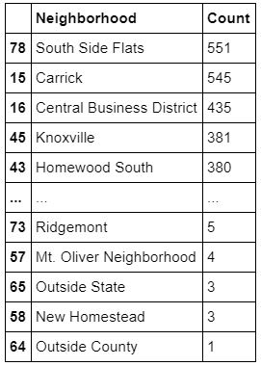

The map below (Figure 2.) depicts which police departments are located within or near neighborhoods that have highest rates of violent crimes. The department in Zone 3 is located in between 3 of the neighborhoods that are in the top 5 ranking above (Figure 1.). The department in Zone 2 is located near one of the neighborhoods that also in the top 5 ranking. The department in zone 5 is also surrounded by neighborhoods that have above 183 crimes per neighborhood.

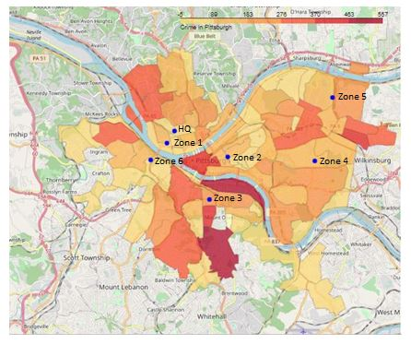

Figure 2. Pittsburgh crime and police department map.

**Discussion**

Upon reviewing the analysis, it is recommended that Departments in Zone 2 and Zone 3 should be prioritized for receiving equipment, personnel and funding. However, this was purely an empirical/observational study and while an increased police presence in these areas may act as deterrent against violent crime and increase police preparedness; other factors would need to be assessed in order to have longer lasting effect in those areas. On way to attempt to have a longer lasting effect in these areas, is to examine the possible root causes of violent crime in those areas. So of the factors that could be examined in the future are the social economic status of each area, employment rates, family structure and access to mental health care. Upon examining these other factors, perhaps researchers can develop a plan to combat the rates of violent crimes in Pittsburgh.

**Conclusion**

The purpose of this study was to identify which of Pittsburgh police departments should be given priority to receive funding, personnel, and equipment based on the rates of violent crimes conducted in or near the locations in which the police departments are located. The data was rearranged and organized so that each neighborhood was ranked according to rates of crime and the depicted accordingly on a map. Once the data was overlaid with the locations of the police departments, it was concluded that police departments in Zones 2 and 3 should be prioritized based on the rates of violent crimes in the surrounding areas. Further research would be needed to examine more variables that could help decrease the prevalence of violent crime in the Pittsburgh area in order to a longer, more significant lasting effect.